

**LG TP-C508TLA1**

**Rs. 94,400/-**

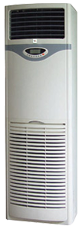

**Product Features**

* Comfortable sleep mode
* Evaporator self-cleaning
* Inner brass screw high efficiency exchange heat
* Auto mode
* Ultra-Thin Design

**Specification**

**Type** Wall Mounted Split AC

**Cooling (Btu/h)** 37000

**Voltage (V)** 220-240

**Power Input (W)** 4200

**EER (Btu/W-h-W/W)** 7.4-2.7